**1. INTRODUCTION**

* 1. **Project Context**

In today’s world, technology plays a big role over all industries especially with regards to business processes, production, manufacturing and managing records and transactions. In the absence of modern technology, there are too many difficulties in keeping up with the company’s demand and the tight competition among emerging businesses. (Chapman, Clive, 2012)

In today's tight economy, suppliers and retailers do not want to carry any more inventories as they have to stock, as excessive inventory increases a company's overhead expenditure. Over the past years, businesses started to employ Just In Time (JIT) inventory methods that are based on a minimum and maximum equation. Companies want to ensure that they have at least the minimum quantity of a given item in stock based on analysis of forecasted sales of a certain given item. The maximum quantity for a specific item characterizes a realistic reserve inventory if the item experiences high demand in sales. (Chapman, Clive, 2012)

Automated inventory system supports a company by providing real time assessment of inventory levels and status. One basic example and benefit of using an automated Inventory system is for a given instance that item is sold, the inventory level for that item is automatically adjusted and when that item's inventory level reaches the minimum level, the system automatically generates a purchase order that can be electronically transferred to the supplier. What happens in reality is that the system keeps track of every item that is nearing to reach the minimum inventory level and compiles a list of all items that needs restocking and being sorted by the supplier. As a result of which, multiple purchase orders coming from different suppliers are generated and transferred to the suppliers with a copy of each purchase orders also transmitted to the respective accounting department. Advantages of implementing automated inventory systems for the company include the following (Chapman, Clive, 2012):

* Stores enough inventories in stock.
* Keeps track inventory levels and automatically issues product order when mandatory.
* Automated transmission of product order to the suppliers offering the best value available.
* Informs the accounting department of what was ordered to what was received.

The study aims to create and provide an automated inventory system for the benefit Priscilla’s’s General Merchandising and replace their current manual method of tracking inventory levels and managing records for the company. It will serve as a great aid for the business owner’s decision-making and what strategies could be implemented for the development and enhancement of the company’s performance.

* 1. **Company Background**

**Priscilla’s’s General Merchandising**

Address: #5 Don Jose Street, Kimco Village, Tandang Sora, Quezon City, Philippines

Telephone Number: (Local 02) 984-1113

E-mail Address: jplexc@yahoo.com

Annual Sales: Php 12,000,000 in the year of 2012

Total Employees: 30 employees

**Primary Line of Business**:

* Novelty Items
* Ladies Accessories
* Men’s Accessories
* Children’s Accessories
* Grooming Materials
* Fashion Jewelries
* Gift Items

**Management Directory:**

* Alexander S. Castillo - Owner of the Business
* Priscilla’s E. Castillo–Owner of the Business
* Jacoby Ausa - Secretary
* Robert Salapare - Distribution department head

**Business Profile**

Priscilla’s General Merchandising is a simple proprietorship, which was organized by Mr. Alexander S. Castillo in the year of 1984 that deals with retail packaging and wholesale distribution of novelty items and is a producer of top class fashion accessories such as Ladies Accessories, Men’s Accessories and Children’s Accessories, Grooming Materials, Fashion Jewelries and Gift Items. It was a simple proprietorship, which was organized in 1984. The company began supplying small department stores in Metro Manila and big companies in provinces with marketing office in within the Metro Manila area. Priscilla’s General Merchandising is currently supplying selected department Stores such as SM Accessories Corporation, Landmark, and Gaisano group of companies. The company runs with 30 employees, each responsible for the operations and business processes with their respective tasks and jobs.

* Industry Snapshot

The overall improvement in the Philippine economy has benefited personal accessories greatly in 2012. The higher disposable incomes resulting from greater employment opportunities have made consumers more inclined towards buying more personal accessories, whether out of need or simply due to fashion concerns.

In 2012, practicality has increasingly become an important consideration when it comes to purchase of personal accessories. This includes a shift in preferences for different types of personal accessories: for example, in bags and luggage, larger handbags are becoming more popular, albeit dependent on fashion trends in Europe and the US. For watches, special features for sports lovers are considered the practical choice.

Department stores continue to play a crucial role in the sales of personal accessories in the Philippines in 2012. This is led by the major chain SM Department Store, which is present in every major city and in large provinces across the nation. The strong performance of department stores is also tied greatly to the chain being present in every SM Mall across the country, which makes it the most accessible retail channel. This is especially true with Filipinos being known for frequenting malls even on a window-shopping basis just to escape the heat, putting department stores in just the right place for impulse as well as planned purchases.

* Background and Development

The nature of the fashion accessories industry in the Philippines lies in its variety of designs, its accessibility to an infinite cornucopia of inventory raw materials (shells, wood, seeds, and other materials found in tropical Philippines), in the workmanship of females who have been traditionally used to producing fine products requiring attention, patience and an aesthetic sensibility, in its simplicity of production which can use child labor, and finally, in its relatively low labor cost.

The industry is a subcontracting system, which encourages competition among suppliers, subcontractors, job-outers and workers over the same orders. There is no written contract between a supplier and their job-outers, nor between the latter and their home workers. However, relationships in the community are such that a verbal agreement is usually kept because breaking it would mean not being able to get workers to do orders for you, or not being given jobs to do again, in the future.

There has been a marked diminution of orders for fashion accessories in the last few years brought about by cheaper labor costs of production elsewhere. Accessories from China, which are way cheaper than Philippine made ones, are competing in the market and winning out. In addition, the accents widely used in finishing and enhancing shell and wood fashion accessories are mainly imported from countries like China.

* Current Conditions

Priscilla’s’s General Merchandising has overall good business standing since it was established in 1984. The business meets the yearly target and remains competitive in the industry. Overall sales for women's accessories rose 12 percent in 2012, whereas their counterpart, women's apparel reported a 7 percent increase in sales. Of all accessory items, small leather goods, belts, scarves, and umbrellas were the only accessories that experienced strong sales in 2009, with fashion sport watches and hats sales with improved sales over 2008 at 10 percent and 16 percent, respectively.

* Industry Leaders

Eppie Labajo is a PATAMABA member whose main production site is located in Laray, San Roque, Talisay, Cebu. In this community, social services are inadequate and incomplete and a large sector of the population is either unemployed or underemployed.

Eppie is recognized for her reliability in the production of fashion accessories. Her principal buyer is a fashion and home décor exporter (Skyhorse Trading) owned by a Taiwanese, with about 200 suppliers. The main target market is abroad but Eppie could not name where her supplies are being exported. Nor does she decide her product lines because these are decided by her buyers, who, also depend on their importer-buyers. Sometimes Eppie makes her own designs, but these are mostly dictated by suppliers or by her gut feel of the market demand. Eppie does not decide her prices either - these are decided by the buyer and negotiated with her, mainly based on the lowest she could go for the cost of labor. Since cost of materials is usually known in advance, this is not much disputed. While Eppie can negotiate the price of raw shells and wood with her local suppliers, she cannot do the same with the accessories and “findings” which some designs may require.

The system of selling/marketing of fashion accessories is mostly dependent on export opportunities. Thus, while marketing of one’s supplies may have begun as an individual effort many years ago (when the fashion accessories industry was just beginning), today, marketing pretty much depends on the supplier’s reputation for making good products; their reliability in executing orders in full and delivering them on time, and the comfort and trust the buyer/agent feels in relation to the supplier. Thus, Eppie promotes her reputation through the quality of her supplies and the satisfaction of her buyers.

In abroad, Victoria's Secret Stores, a subsidiary of Intimate Brands, Inc., discovered success in the 1980s by introducing a new approach to lingerie and accessories sales. The business was started in 1977 with $40,000 and grew quickly. By 1982, it operated five stores and generated $6 million in sales. In addition to the Victoria's Secret Stores, developed successful lingerie and accessories catalog service. The concept saw tremendous success and rapid growth. In 1982, the company expanded to more than 700 stores.

* Workforce

According to the Philippine Bureau of Labor statistics, women's accessory and specialty stores employed more than 55,000 people in 2001. Like much of the retail industry, accessory and specialty stores provide low-paying sales jobs, which are sometimes supplemented with a commission based on sales. There is heavy use of part-time employees. Management occupations accounted for roughly 2.5 percent of all jobs.

* Key business functions

|  |  |
| --- | --- |
| **Key Business Functions** | **Description** |
| **Top Management** | * Responsible for entire enterprise; translates policies into goals, objectives and strategies |
| **Production and Operations** | * Responsible for the packaging of manufactured goods and accessories |
| **Accounting** | * Responsible for auditing and financial analysis |
| **Secretariat** | * Responsible for paper works and documentations |
| **Distribution** | * Responsible for supplying and distribution of finished products to the company’s clients |

*Table 1.0 – Key Business Functions*

**Industry Information Competitive Analysis**

Through our research and interviews, we found out that companies dealing with fashion items face stiff competition, much more with family accessories. There are several similar products, so the company must be innovative. Merchandise could still be developed into a different one by improving the packaging, alteration of some style, and addition of other accessories to make it appear totally different finished good. Pricing is very significant. Timing of bringing the product into the department stores by knowing the present trend is very essential.

**Key Processes**

The key processes of the company are Production, Sales, and Accounting. The first process is the production phase where manufactured accessories coming from an international and local suppliers that is to be purchased by the company will undergo in retail packaging then it will be placed in the company’s storage facility and it will be delivered to accessories, gift items, and fashion jewelries section in department stores of Shoemart, Landmark, and Gaisano group of Companies. The second process is the sales phase where the said products will be sold by the company to the said stores above purchase cost. The third or last process is the accounting phase where books of accounts are prepared and kept for company’s use and as required by government agencies like the city hall and the Bureau of Internal Revenue.

* 1. **Purpose and Objective**

The objective of the project is to improve the manual processes or the traditional way of searching of products of the company. The proposed system will help in creating an integrated automated inventory and online system for Priscilla’s General Merchandising to support the development of tracing inventory/stock status and handling transactions and sales records essential for the company. The online system will aid the company owner and the user of the system to check the status of the inventory even he/she is not in range in the company’s establishment. With the use of the Internet and the online system linked and to the inventory system, the company owner and the user could access inventory records with ease and at a real time basis. Furthermore, the user will not lose track of what is happening in every department related to the business processes and help improve the overall company performance.

The following are the objectives that the project team would like to achieve by the of the study:

* To help Priscilla’s’s General Merchandising to track inventory goods from production until the distribution of finished products. In this way, the company will lessen the cost of loss inventories for the reason that every goods are monitored from production to distribution. This will help eradicate errors such as overstocking and under stocking items in the warehouse.
* To improve production speed and efficiency by the integration of technology and to monitor the products systematically that can also generate reports to help the company owner in decision making.
* To be able to integrate technology that will help facilitate records of transactions that are normally presented in a physical file. In this way, the company owner can view transaction records and receipt with reliabilty and at a fast rate.
* To be able to produce business reports about the status of inventory goods, sales and revenue of the company that will aid the company owner on what are the business strategies that he must follow.
  1. **Scope and Limitation**

This project is intended to improve the service of Priscilla’s’s Merchandising Inc. This includes on how would the new system need new improvements. The study also elaborates on how the system will improve the existing manual process done by the company like searching the products one-by-one that it takes so much time in terms of ease of use, speed, accuracy, and effectiveness.

There was only one recording system used in Priscilla’s’s Merchandising Inc. which was the traditional way on which tallying takes longer since it’s done manually hand-on-hand. Furthermore, the study was confined to getting responses to the business owner to know more details about the system flow.

* 1. **Project Methodology**

The project will be using the waterfall method of Software Development Life Cycle (SDLC) which is structured on the development of a software product. The said method has 5 steps. This includes Requirements Phase, Design Phase, Coding Phase, Testing Phase, and the Maintenance Phase. During the requirements phase, the team will enlist all the necessary requirements needed for the project development. In the next phase which is the design phase, the team will develop or plan for the proposed solution for the system. During the Coding Phase, the team will execute the program or will start to implement the proposed solution for the company in the said solution. During the Testing Phase, this is where the client will test whether the anticipated system is ready for use and it is applicable for the company. Lastly during the maintenance phase, the team will improve the system and also for support.

* 1. **Project Milestones and Timeline**

The project milestones and timeline must be presented in both table and Gantt chart format. The table format must indicate the specific owner(s) of the milestone while the gantt chart should indicate/highlight the critical path and important dates. Below is the recommended Milestone/Timeline based on the 1st Semester’s curriculum schedule. Please include the forecasted schedule until Thesis 2 (Technical Analysis, Development, Roll-out, Training, etc.)

|  |  |
| --- | --- |
| **PHASE 1** | |
| 1. **Planning** | |
| 1. Project Team with Roles and Responsibilities | December 14 |
| 1. IS Capstone Project Topic Approval | December 14 |
| 1. Concept Paper | December 21 |
| 1. **Requirements Definition** | |
| 1. Data Gathering and Business Process Analysis | January 18 |
| 1. Chapters 1 & 2 | January 23 |
| 1. Interview | January 30 |
| 1. Chapter 3 | January 29 |
| 1. Chapter 4 | February 4 |
| 1. Interview | February 8 |
| 1. **Pre-oral Defense** | |
| 1. Submission of PowerPoint and Project document | February 5 |
| 1. Mock Presentation | February 7 |
| 1. **Oral Defense** | |
| 1. Submission of PowerPoint and Project Document | February 18 |
| 1. Mock Presentation | February 19 |
| 1. **Project and Document Completion** | |
| 1. Sign-off thesis panel members | March 1 |
| 1. Post-project review(lessons learned, project review) | March 2 |
| 1. Completion and submission of all project outputs | March 2 |
| **II. Phase 2** | |
| 1. **Technical Analysis** | |
| 1. Create a flow for the system | June 24 |
| 1. Design the system interface | July 1 |
| 1. **Development and Testing** | |
| 1. Gather all tools needed | July 8 |
| 1. Develop the system | July 22 |
| 1. Completion | August 26 |
| 1. Testing for bugs | Sept 2 |
| 1. **Training** | |
| 1. Orient the upcoming administrator for the system flow | Sept 9 |
| 1. The upcoming admin’s exploration and experiencing of the new system | Sept 16 |
| 1. Go-Live & System Handholding | Sept 23 |
| 1. Post Project Review/ Lessons | Sept 30 |

*Table 1.1 – Project Milestones and Timeline Table*

**Gantt Chart**

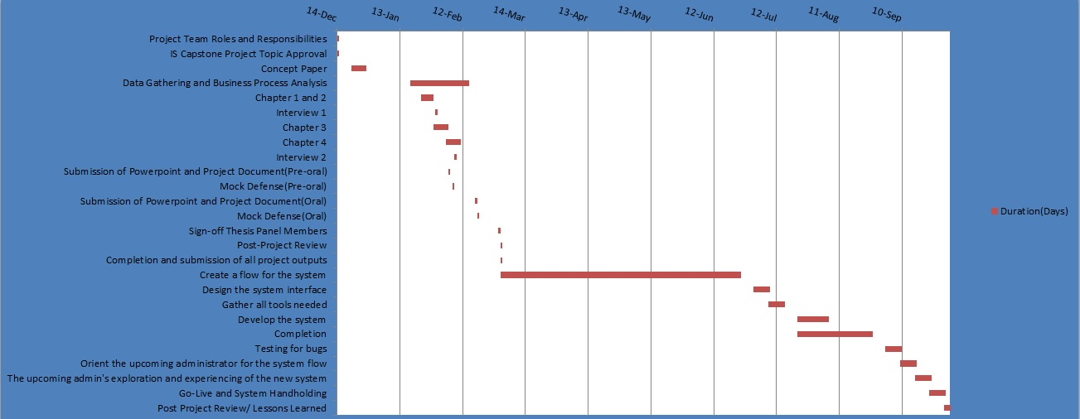

**2. REVIEW OF RELATED LITERATURE AND STUDIES**

Inventory is the stock of any item or resource used in and organization. An inventory system is the set of policies and controls that monitor levels of inventory and determine what level should be maintained, when stock should be replenished, and how large orders should be. By convention, manufacturing inventory generally refers to items that contribute to or become part of a firm’s product output. Manufacturing inventory is typically classified into raw materials, finished products, component parts, supplies, and work-in-process. In services, inventory generally refers to the tangible goods to be sold and the supplies necessary to administer the service (Jacobs, 2008).

The basic purpose of the inventory analysis in manufacturing and stock keeping services is to specify (1) when items should be ordered and (2) how large the order should be. Many firms are tending to enter into longer-term relationships with vendors to supply their needs for perhaps the entire year. This changes the “when” and “how many to order” to “when” and “how many to deliver” (Chase, 2008).

Inventories are materials and supplies that a business or institution carries either for sale or to provide inputs or supplies to the production process. All businesses and institutions require inventories. Often they are a substantial part of total assets. Financially, inventories are very important to manufacturing companies. On the balance sheet, they usually represent from 20% to 60% of total assets. As inventories are used, their value is converted into cash, which improves cash flow and return on investment. There is a cost for carrying inventories, which increases operating costs and decreases profits. Good inventory management is essential (Arnold, Clive, 2012).

Inventory management is responsible for planning and controlling inventory from the raw material stage to the customer. Since inventory either results from production or supports it, the two cannot be managed separately and, therefore, must be coordinated. Inventory must be considered at each of the planning levels and is thus part of production planning, master production scheduling, and material requirements planning. Production planning is concerned with overall inventory, master planning with end items, and material requirements planning with component parts and raw material (Arnold, Chapman, 2012).

**Purpose of inventory**

All firms (including Just in Time operations) keep a supply of inventory for the following reasons:

1. To maintain independence of operations. A supply of materials at a work center allows that center flexibility in operations. For example, because there are costs for making each new production setup, this inventory allows management to reduce the number of setups. Independence of workstations is desirable on assembly lines as well. The time that it takes to do identical operations will naturally vary from one unit to the next. Therefore, it is desirable to have a cushion of several parts within the workstation so that shorter performance times can compensate for longer performance times. This way the average output can be fairly stable.
2. To meet variation in product demand. If the demand for the product is known precisely, it may be possible (though not necessarily economical) to produce the product to exactly meet the demand. Usually, however, demand is not completely known, and a safety or buffer stock must be maintained to absorb variation.
3. To allow flexibility in production scheduling. A stock of inventory relieves the pressure on the production system to get the goods out. This causes longer lead times, which permit production planning for smoother flow and lower-cost operation through larger lot-size production. High setup costs, for example, favor producing a larger number of units once the setup has been made.
4. To provide a safeguard for variation in raw material delivery time. When material is ordered from a vendor, delays can occur for a variety of reasons: a normal variation in shipping time, a shortage of material at the vendor’s plant causing backlogs, an unexpected strike at the vendor’s plant or at one of the shipping companies, a lost order, or a shipment of incorrect or defective material.
5. To take advantage of economic purchase order size. There are costs to place an order: labor, phone calls, typing, postage, and so on. Therefore, the larger each order is, the fewer the orders that need be written. Also, shipping costs favor larger orders - the larger the shipment, the lower the per-unit cost.
6. Many other domain-specific reasons. Depending on the situation, inventory may need to be carried. For example, in-transit inventory is material being moved from the suppliers to customers and depends on the order quantity and the transit lead-time. Another example is inventory that is bought in anticipation of price changes such as fuel for jet planes or semiconductors for computers.

For each of the preceding reasons (especially for items 3, 4, and 5), be aware that inventory is costly and large amounts are generally undesirable. Long cycle times are caused by large amounts of inventory and are undesirable as well (Jacobs, Chase 2011).

**Inventory and flow of material**

There are many ways to classify inventories. One often-used classification is related to the flow of materials into, through, and out of a manufacturing organization. The first classification is the raw materials which are purchased items received that have not entered the production process. They include purchased materials, component parts, and subassemblies. Second is the work-in-process (WIP) which are raw materials that have entered the manufacturing process and are being worked on or waiting to be worked on. Third on the list is the finished goods wherein it is the finished products of the production process that is ready to be sold as completed items. They may be held at a factory or central ware- house or at various points in the distribution system. The fourth classificatio is the distribution inventories that is the finished goods located in the distribution system. Lastly, the maintenance, repair, and operational supplies (MROs) that describes items used in production that do not become part of the product. These include hand tools, spare parts, lubricants, and cleaning supplies.

Classification of an item into a particular inventory depends on the production environment. For instance, sheet steel or tires are finished goods to the supplier but are raw materials and component parts to the car manufacturer (Arnold, Clive, Chapman, 2012).

**Inventory Systems**

Keeping track of inventory is vitally important for any successful retail enterprise. Inventory systems let you know when it is time to stock up on items that are running low and can also prevent you from overselling products and then having to inform customers that their items are either unavailable or must be backordered. Inventory systems can provide insight into which products are selling well and which products are selling poorly. With this information you can make intelligent decisions on how to maximize your sales and make your Web site more effective (Smith, 2009).

An inventory system provides the organizational structure and the operating policies for maintaining and controlling goods to be stocked. The system is responsible for ordering and receipt of goods: timing the order placement and keeping track of what has been ordered, how much, and from whom. The system also must follow up to answer such questions as: Has the supplier received the order? Has it been shipped? Are the dates correct? Are the procedures established for reordering or returning undesirable merchandise? (Buffa, Taubert, 2007).

This section divides systems into single-period systems and multiple-period systems. The classification is based on whether the decision is just a one-time purchasing decision where the purchase is designed to cover a fixed period of time and the item will not be reordered, or the decision involves an item that will be purchased periodically where inventory should be kept in stock to be used on demand. We begin with a look at the one-time purchasing decision and the single-period inventory model (Jacobs, Chase, 2011).

**Inventory Systems Features**

The Inventory System in Commerce Server comes with many important features that aid in the real-time management of inventory for items in your catalog. These features allows the system to display th Display real-time inventory conditions of your products and product variants, including in stock, out-of-stock, back-ordered, or pre-orderable; Filter products and product variants listings to show only those products that are currently available in stock; decrement inventory levels when orders are processed; receive notifications when inventory levels reach an out-of-stock threshold; integrate inventory levels with LOB applications and lastly, gain insight into how well products and product variants are selling (Gaither, Frazier, 2008).

**Nature of Inventories**

There are two fundamental issues underlie all inventory planning on how much to order of each material when orders are placed with either outside suppliers or production departments within organizationsand when to place the orders.Order quantities, sometimes also called lot sizes, and when to place these orders, called order points determine in large measure the amount of materials in inventory at any given time.

The study of the inventory cycle materials are ordered, received, used and the process is repeated- uses a terminology all its own.Inventories may contain materials that have either dependent demand or independent demand. In independent-demand inventories, the demand for an item carried in inventory is independent of the demand for any other item carried in the inventory. Demands for these items are estimated from forecasts or actual customer orders. Dependent-demand inventories consist of items whose demand depends on the demands for other items also held in the inventory (Gaither, Frazier, 2008).

**Elements of Inventory System**

Inventory systems are extraordinarily diverse, and they differ along many dimensions. Every inventory lies between two activities or processes, which are the supply process and the demand process. The supply process comprises the production, transportation, and other activities that increase new stock to the inventory. On the otherhand demand process describes the various activities that use and decrease material from the inventory and the possibility and practicality of an ideal supply process, of course, depend in part on the nature of the demand process (Zipkin, 2009).

**Demand process**

Smooth or lumpy demand is when demand can be envisioned as a continuous stream, drawing down inventory at some rate, then we say demand is smooth. Lumpy demand, in the other hand, occurs in large, discrete chunks. Variations in demand over time is the seasonal changes in demand, and other temporal variations, often lead to mismatches, especially when the capacity of the supply process is very limited. Unpredictable demand variations are the random instabilities in demand, in conjunction with supply lead times and capacity limits, are among the major reasons for maintaining inventories (Zipkin, 2009).

**Supply process**

Economies of scale in supply in many situations the technology and economics of the supply process favor long production runs or large deliveries, relative to short term demand. Capacity limits means that every real process has limited capacity, and so has limited ability to respond to changes or lumps in demand, whether anticipated or not. Delays in response, also called as the lead times is defined as supply lead times and demand fluctuations together lead to shortages, unless inventories are held to prevent or at least reduce them. Imperfect Quality exacerbates many of the problems discussed so far. Defects waste precious capacity, and they add elements of uncertainty to the supply process, somewhat like random lead times (Zipkin, 2009).

**Concentration of Inventories within Industries**

Inventory is driven by demand and supply. To control an inventory system, it is necessary to monitor and record demands and supplies as they occur. Perhaps it is, still, many companies neglect these basic chores. (Zipkin, 2009)

Because firms compete in different ways, and have different production processes, their inventories are concentrated in different areas. In some industries, the inventories are primarily in raw materials, in others are in finished goods; and for others they are concentrated in work-in-process. For the manufacturers of railroad rolling stock production is carried out primarily to specific customer order. For the apparel and novelty items industry, most of the inventory investments is tied up in work-in-process, in readiness for a quick response to cues from the marketplace (Silver, Pyke, Peterson, 2008).

Rubber products, such as automobile tires, can be stored as finished goods relatively easy, and at relatively low cost. Production equipment often is highly utilized and is expensive to shut down, so it is difficult to meet varying demand by adjusting production rates. Therefore, most of the inventories held at the finished goods stage. (Silver, Pyke, Peterson, 2008)

**Related Studies**

**Microsoft Commerce Server 2007**

Commerce Server 2007 introduces a new Inventory System for the real time management of inventory items in the catalog. The Inventory System supports updating inventory information for all items, monitoring inventory depletion, and importing and exporting inventory information to and from external systems of record. The Inventory System serves the needs of shoppers, business managers, site administrators, and external line-of-business systems that interface with Commerce Server.

The Commerce Server 2007 inventory system includes support for the following functions:

* Flexible configuration that allows for backordering and display of out of stock stock-keeping units (SKUs).
* Order checking and update through pipeline components.
* Full text search and query integration with the Catalog System.
* Transactional updates.
* Import and export operations similar to the Catalog System.
* Runtime APIs with methods for searching, browsing, viewing details, inventory search options that include product filtering, assigning inventory conditions, and roll-up values.
* Integration with other Commerce Server systems, such as the Catalog System and Orders System.
* Integration with Microsoft BizTalk Server; import and export APIs to support line-of-business systems integration.

**SAP**

SAP is an Enterprise Resource Planning (ERP) system that helps businesses manage supply chains. As supply chains grow in complexity and evolve into supply networks, they become more obscure. Identification of waste becomes paramount as inefficiency grows and critical visibility decreases. Identifying problem processes becomes difficult. This in turn causes frustrating delays, bloated inventories and higher costs. SAP gives you and your supply-network colleagues fast access to supplier information, creating a transparent supply network that fosters efficient collaboration for a more agile and responsive

supply network.

SAP supply-chain management (SCM) ships with several components installed that allow the system to track, record and share inventory information among all parties in the supply chain. SAP uses a component called the SAP Inventory Control Hub to share inventory, audit transactions and log communications for reference over the Internet. The SCM includes a Vendor Management Inventory, or VMI system. The VMI allows vendors to transmit supply levels and other vendor data to the SCM system. The vendor can use the VMI in the SAP Supply Chain Management solution to manage supply concerns without an expensive out-of-pocket investment in an inventory-supply control system.

Regardless of what inventory-supply management software is used, a management system has to perform several essential functions. The SAP supply-chain management system comes with a variety of ability set, including a large array of supplies. A supply-chain management system must be able to handle increased inventory load and use alerts to notify suppliers of needed merchandise. SAP uses customized automated alerts based upon agreed upon criteria. Alerts can be sent via many different communication channels: cell phone, email and even pagers. Vendors can update the SAP installation through email or a Web browser. SAP in-place system acts on inventory levels through the use of Extensible Markup Language (XML). It interacts with many different planning and transaction systems. SAP brings suppliers up-to-date fast and keeps them informed.

**3 BUSINESS PROCESSES**

**3.1 Priscilla’s’s General Merchandising Existing Inventory Process**

1. **Production**  
   Items are purchased from local suppliers from abroad. Samples are distributed to prospective department stores and regular customers like Shoemart, Landmark, and Gaisano group of companies. Purchase Orders from Shoemart are downloaded from their website while other department stores prepared their purchase orders manually. Items ordered are separated for distribution to customers. Remaining inventories are placed in the storages and offered to buyers regularly.
2. **Sales**  
   Approved purchase orders are arranged according to delivery schedules by customers. Items are repacked and prepared for delivery to customers. Sales invoice is prepared per purchase order, which also serve as delivery receipt. In Shoemart, collection in automatically credited to company’s bank discount. All other department stores collection is done manually; counter receipt is issued for the total amount of sales invoice. Upon collection check is received for total amount of counter receipts.
3. **Accounting**  
   Books of accounts are prepared and kept for company’s use and as required by government agencies like city hall and BIR for auditing purposes. Separate records for purchases and sales are done regularly. Official receipts from suppliers and check vouchers are the documents for purchases while sales invoices and check collection and remittances thru credit memo to bank account are kept for sales records.

* Value added taxes are computed monthly using purchases and sales book of accounts for payment to BIR.
* Quarterly reports are submitted to BIR on Sales and Purchases per customer.
* Financial Statements are prepared quarterly to determine income for company’s record and for tax purposes.
* Annual reports and financial statement are prepared for income tax return purposes and for company’s evaluation of performance during the year.
* Annual budget are prepared as company’s guideline in managing the business to attain company’s objective.

IV. **Inventory Management Process**

Priscilla’s’s General Merchandising adopts the First in, First Out (FIFO) method of handling inventories. The company maintains book to record movement of merchandise. Each item purchased is assigned a stock number, unit cost, and quantity. Subsequent purchases with the same particulars are recorded in the book under a specific stock number where the items belong.

Upon receipt of purchase orders from customers, the existing inventory is determined to know the required quantity needed. Purchases are added to beginning inventory.

Items sold are deducted from inventory totals. Running balance of ending inventory is indicated in each stock number

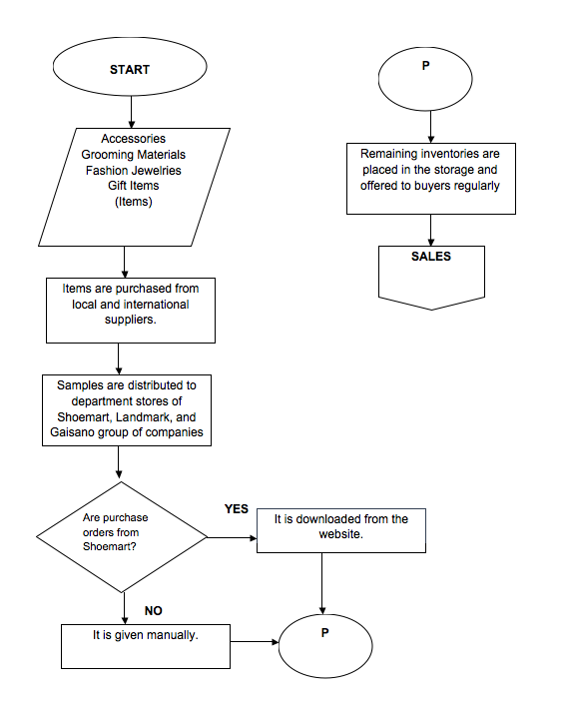Figure 3.1 *Production Phase*

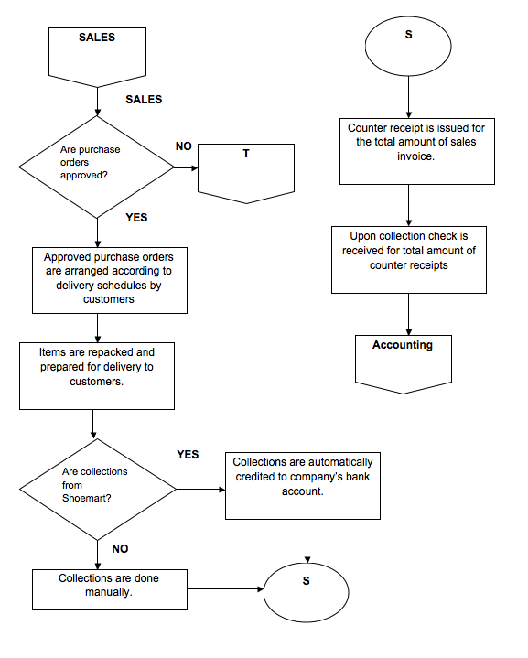Figure 3.2 *Sales Phase*

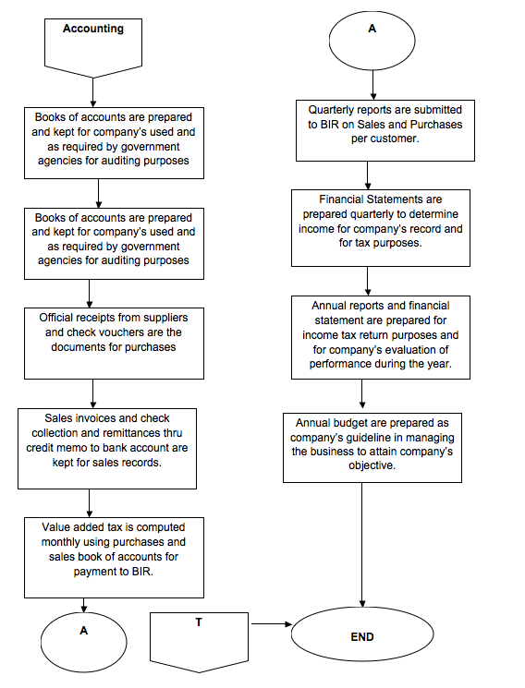Figure 3.3 *Accounting Phase*

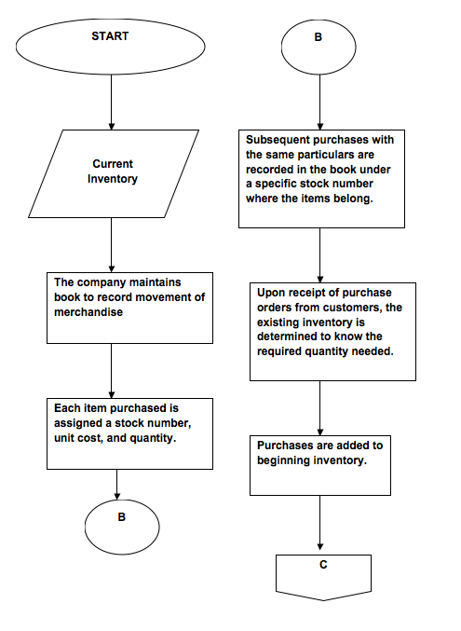

Figure 3.4 *Inventory Management Phase*

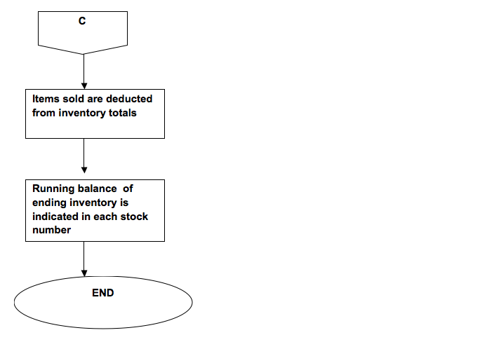

Figure 3.4 *Inventory Management Phase (continued)*

**3.2. Business Requirements Overview**

The system will give benefits to inventory balance, inventory turnover, repeat customers, accurate planning, warehouse organization, employee efficiency, inventory orders, inventory tracking, time saving and cost cutting. The system will be work efficiently with these proponents especially that this will be an online based system. The project aims to fulfil and easier process for managing and locating objects or materials. This system will provide critical information about the condition of the products, such as whether you are low on stock and your inventory needs to be replenished. This will also provide the users and accurate information, letting them know when items are out-of-stock, back-ordered, or pre-orderable in a way that it the user can check it with the use of the online system.

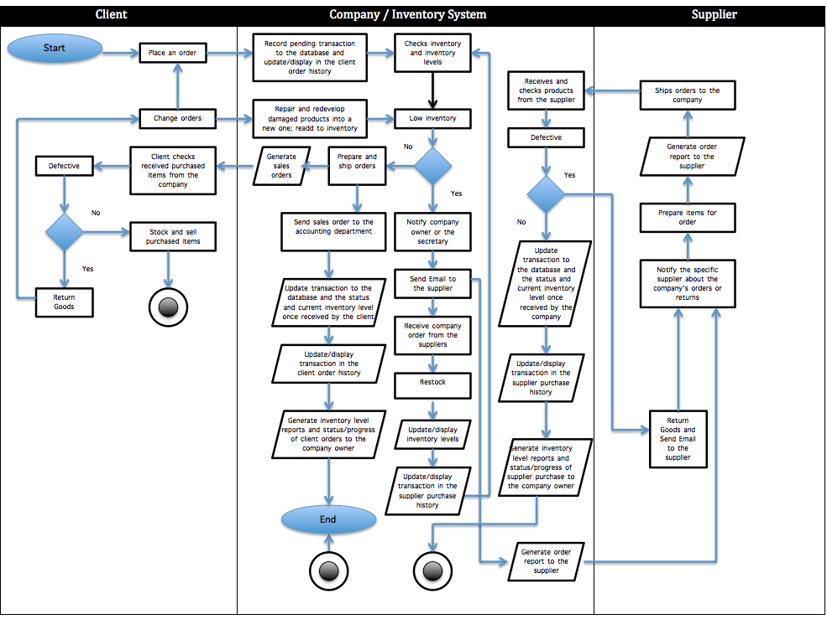Figure 3.5 *Proposed Inventory System Flowchart*

**4.** **BUSINESS SOLUTIONS**

The main solution for the business is to help Priscilla’s’s General Merchandising to track inventory goods in a faster way from production until the distribution of finished products and also for making transactions faster. With the help of our proposed system which is the inventory system, it can help the business improve the manual processes done by the company. Inventory system could also improve the speed and efficiency done in traditional way where the owners don’t need to find products in a manual way, they could just login into an online inventory system and they could find the desired product/s they want and also they could just see the quantity of products they want to see ordered for Shoemart, Landmark, and Gaisano group of Companies. They could also see the sales of their orders. Online inventory system is very reliable and very helpful for the business.

4.1 **Functional Requirements**

The proposed system will greatly improve the way of the system from the manual recording system to an online based system. The inventory system must be able to: create a database for the goods/accessories that will be sold, show detailed information on goods including the description and price of the product, display the availability of the product which can be viewed by the user anytime just by having an internet connection, create a state event where the system will send a notification to the supplier if the inventory is low in stock and needs to be refilled, update every transaction to the database and track previous transactions and records.

The system will work efficiently with these proponents especially that this will be an online based system. The project aims to accomplish easier process for managing and finding objects or resources. The owner/administrator of the Priscilla’s’s General Merchandising can view and study the transaction recorded in the database easily and with more accurate information so that they can compute their sales, expenses and profits with less errors.

**4.2 Mock-ups**

* **Main Page**

4.2.1 **Login**

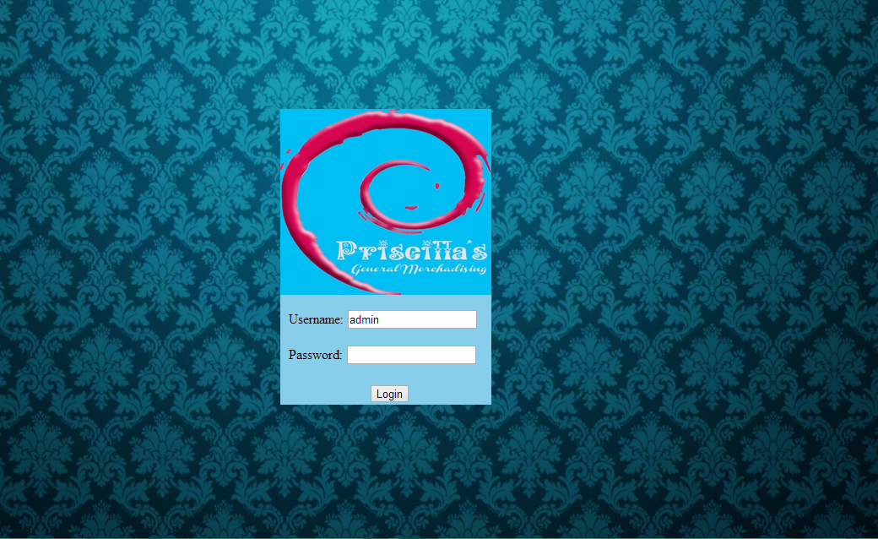The screenshot below is the login page for the administrator. The user must be an administrator to login. The user should fill in valid username and password for the user to view the website.

*Figure 4.1 – Login Page*

4.2.2 **Home**

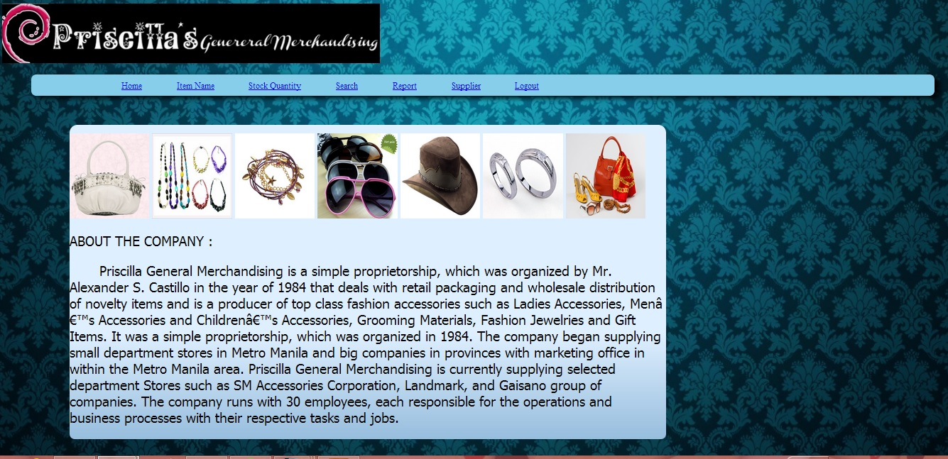In this figure is where the user could see the homepage. This is where he could see the company's brief details or brief introduction and also this is where he could see the featured items/accessories of the company.

*Figure 4.2 – Home Page*

4.2.3 **List of Clients**

On figure 4.3, the lists of clients are shown. The contents are the Client ID, the Client Name, Branch, Phone Number, Email, and a show Order History Button. The Client ID is system generated. The Client Name, Phone Number and Email is based on the registration on the client portal. The Location address is based on the client’s available Branches. It is enlisted in a drop-down list with the default address as all branches. When the Order History is clicked. The administrator will be directed to clients order history that will be shown on Figure 4.4.

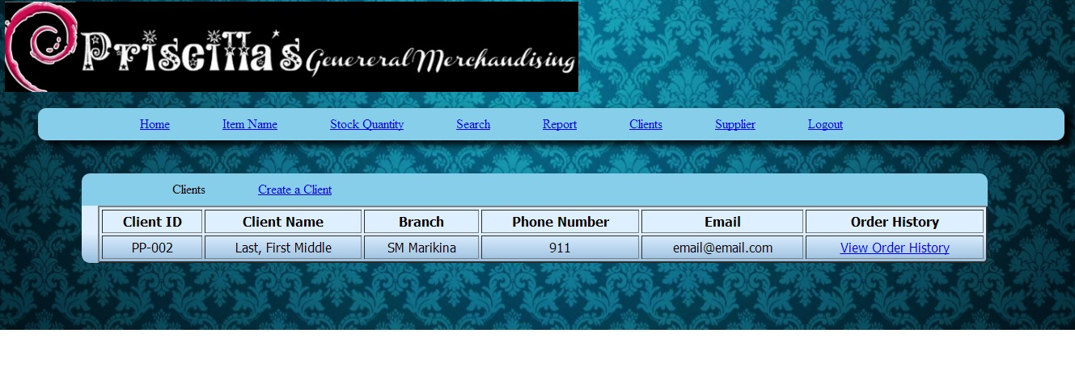

*Figure 4.3 – List of Clients Page*

4.2.4 **Order Summary**

In figure 4.4, shows the order history made by the client. This is also the order history tab. The contents are the Client ID, Client Name, Location, Product ID, Department, Product Name, Quantity, Date Ordered, Date Received, Lead Time, and Terms & Conditions. The Client ID and Product ID are system generated. The Client Name is based from what the administrator has clicked from the order history. The Location details are based from where the item has shipped. The department details are the category of the items. The quantities are the remaining items left for the items. The date ordered is when the item was ordered. The date received was when the client received the item. The lead-time is the time is based from the interval of the date ordered and date received. The Terms and conditions is the time expected to deliver the products. The user may also print the report.

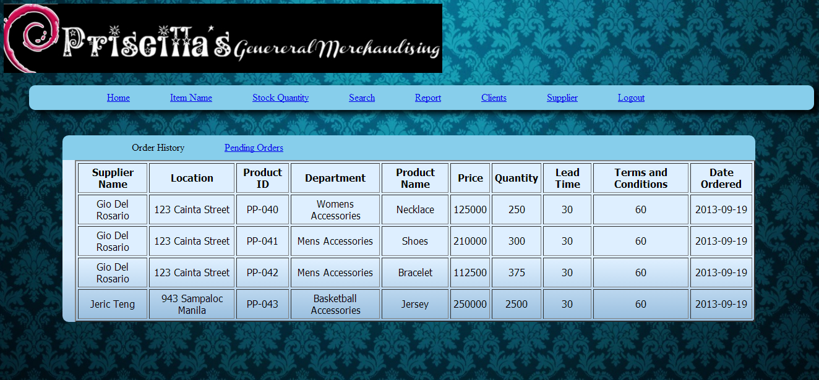

*Figure 4.4– Order Summary Page*

4.2.5 **Pending Orders**

In figure 4.5 shows that pending orders from the client. The details show the same as the order history but this shows the status of the pending order whether it was received or shipped.

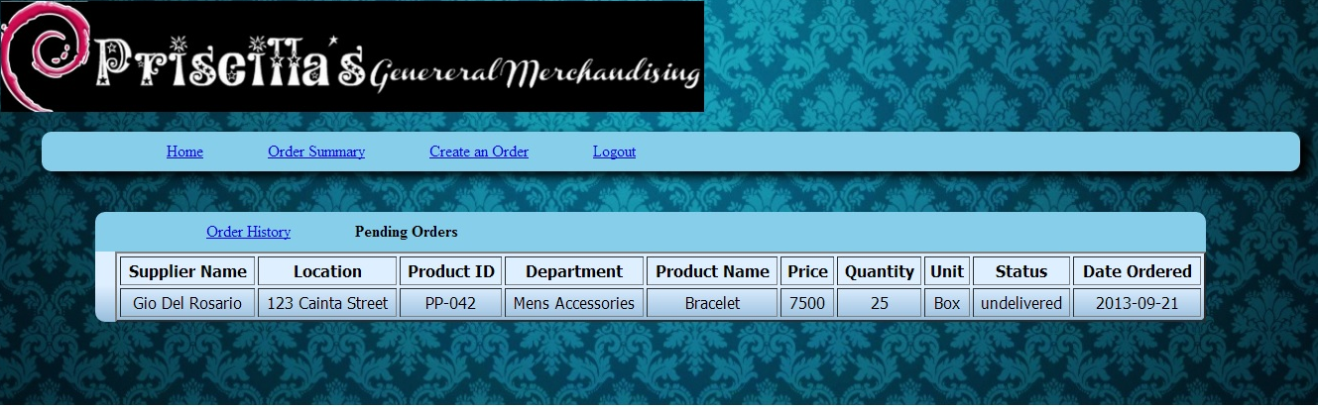

*Figure 4.5 – Pending Orders Page*

**4.2.6 Create Clients**

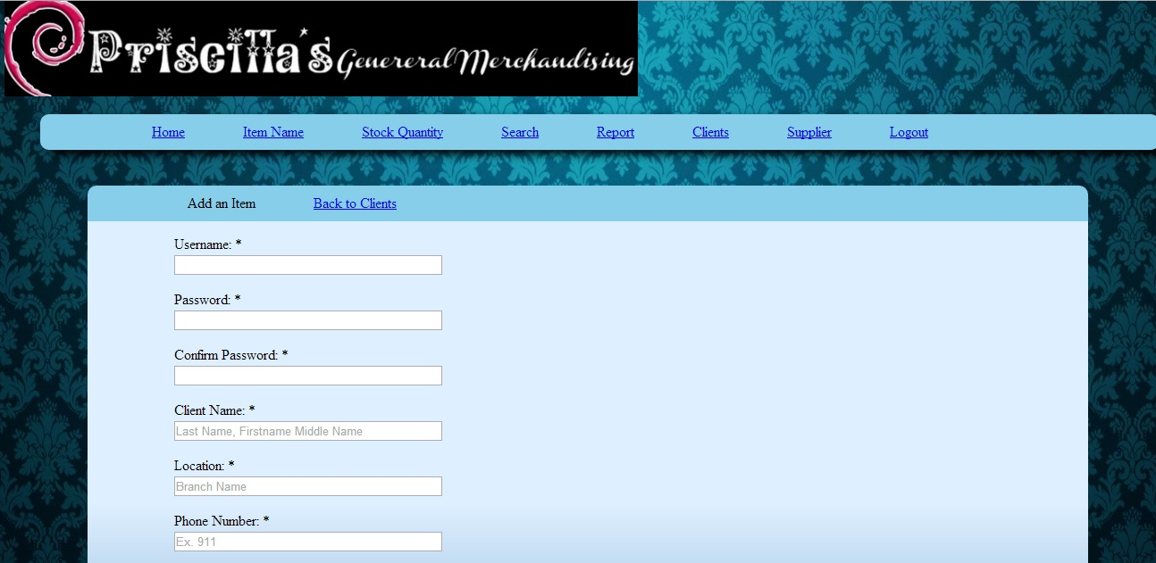In figure 4.6 shows the fill up form for the administrator to sign up his respective client. The contents of the fill-up form are username, password, confirm password, client name, location, phone number, and email. The user could fill in this form for the client and can register them in the system.

*Figure 4.6 – Create Clients Page*

4.2.7 **List of Suppliers**

In figure 4.7 shows the list of supplies for both international and local. As for the default page, it would display the international list of supplies. The table shows The Supplier ID, Location, Company Name, Company Number, Supplier Contact Number, Person to contact in case of emergency, Emergency Person’s Number and Purchase History Button. Supplier ID is system-generated. Location is depending whether an international one, or a local one. When it is an international one, country must be provided. When it is a local one, the location within the country must be provided. Purchase History Button is show on figure 4.6.1.

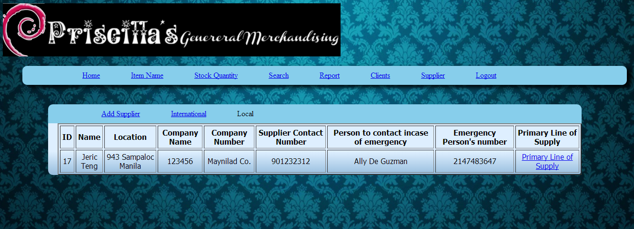

*Figure 4.7.1 – List of Suppliers - Local Page*

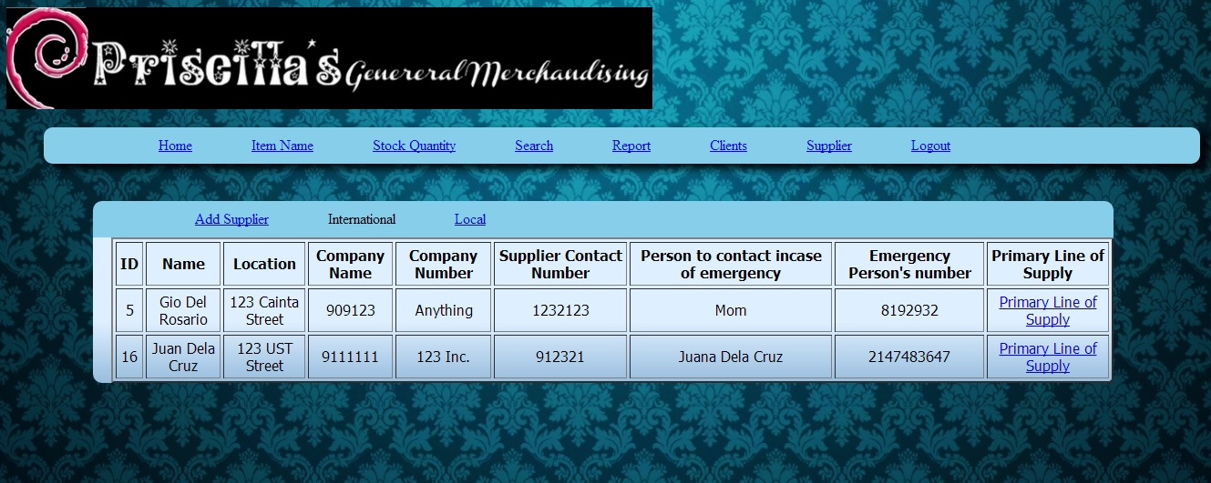

*Figure 4.7.2 – List of Suppliers – International Page*

4.2.8 **Purchase History**

In this figure 4.8, it shows the Purchase History made by the supplier. The contents of the table are the Supplier ID, Address, Product ID, Department, Product Name, Quantity, Price, Lead Time, and Terms & Conditions. The Supplier ID and the Product ID are system-generated. The Address is based on the Address on the supplier. The Department is based on the item of the Product Name column. The quantity states the remaining quantity of the item. The prices are based per piece. The lead-time calculates on the interval of the date ordered and the date received and the Terms & Conditions are the days when will it be expected to be delivered. The user may also print this report and may use the search bar for easy viewing.

*Figure 4.8 – Purchase History Page*

4.2.9 **Primary Line of Supply**

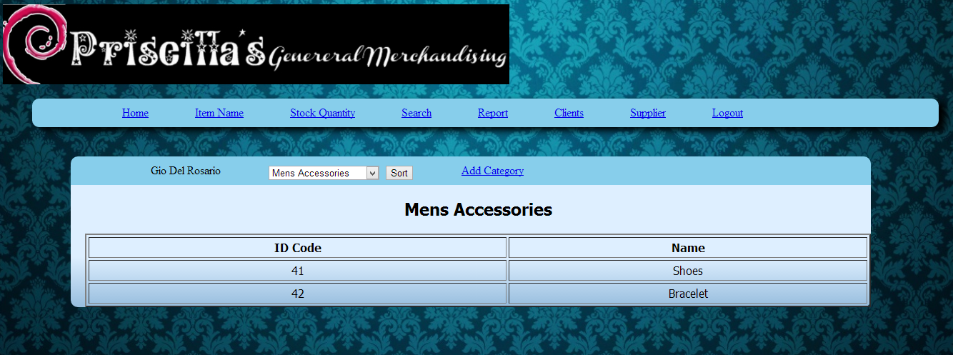 In this figure 4.9, it shows the primary supply of a certain supplier. The user could pick a category for the items he wants to search. After clicking the sort button, it will automatically show a table of items depending on the category the user picks.

*Figure 4.9– Primary Line of Supply Page*

4.2.10 **Item Name**

In figure 4.10, it shows the user the items/accessories for the company. The contents of the table are Item Code, Item Name, Description, Category, Unit, Unit Price, Selling Price, Supplier/Customer. Item Code is system-generated. The Item name is based on which category and number it belongs. Description is a simple detail of status of a specific item. Unit is either on boxes or on pieces. Category is whether it is ladies accessories, children’s accessories or men’s accessories stock. Unit Price is the price that the company purchases a specific item. Selling price is the price that the company set an amount to an item. Supplier and Customer is based on who the company will supply to or sell to.

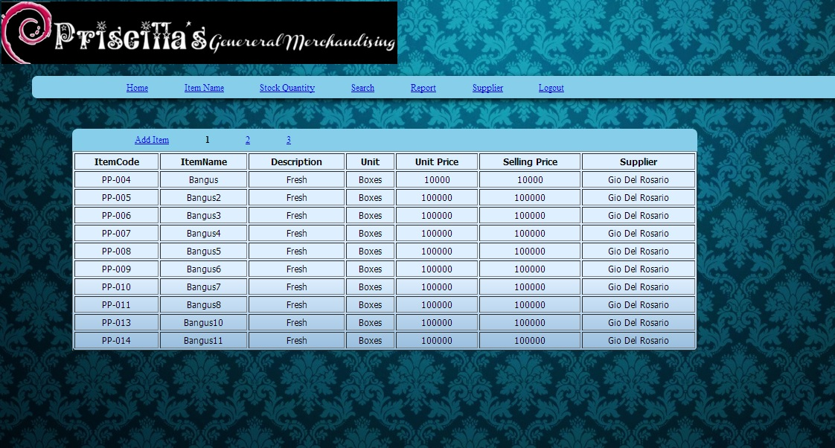

*Figure 4.10– Item Name Page*

4.2.11 **Add Item**

In figure 4.11, the user could fill in several fields. These fields are item name, description, unit, unit price, selling price, quantity, supplier, customer, and number of damaged. Item name is based on the accessories the company is selling. Unit is either in boxes or in pieces. Unit Price is the price that the company purchases a specific item. Selling price is the price that the company set an amount to an item. Supplier and Customer is based on who the company will supply to or sell to. There is also an active and inactive radio button, which the user could fill for the customer or supplier whether they are active, or not. Add Item is both under Item name tab and Stock Quantity tab.

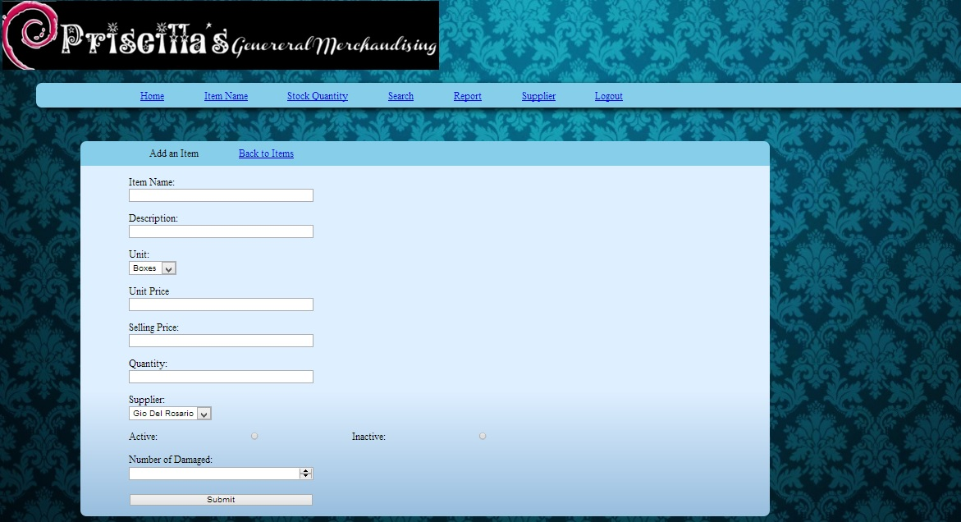

*Figure 4.11 – Add Item Page*

4.2.12 **Stock Quantity**

In figure 4.12, it shows the stock quantity of the company. The contents of the table are Item Code, Item Name, Unit, Current Quantity, Supplier, Number of Damaged, Total Quantity, Edit Item, and Delete Item. Item Code is system-generated. Item name is the item or the accessory sold by the company. Unit is either on boxes or in pieces. Current Quantity is the current number of items per category in the inventory that is not damaged. Number of Damaged is the number of items per category that is not ready for sale or can be on repairing phase. Total Quantiy is total number of items for sale and the items that are damaged. Edit Item is where the user could update the status of the item. Delete Item is where the user could delete a specific item when it is not for sale anymore or it is already delivered and there are new items to be sold. The user could also see the critical items of the inventory when clicking the stock quantity button. It will prompt the user for the critical items. Critical Items are marked red in the table.

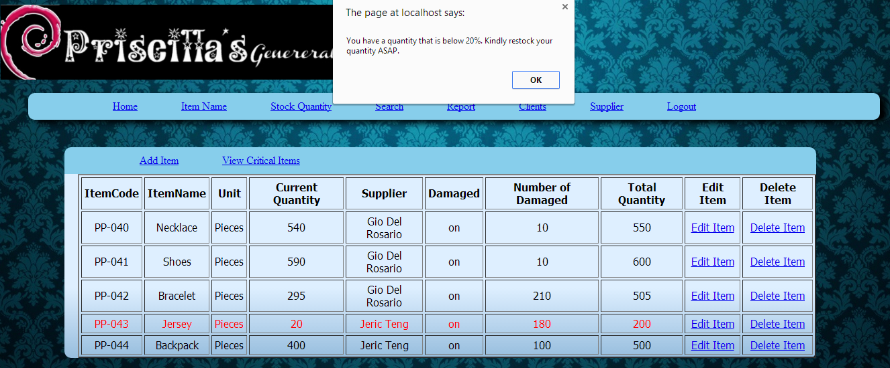

*Figure 4.12 – Stock Quantity Page*

4.2.13 **View Critical Items**

In figure 4.13, it will show the user the critical items of the inventory. The contents of the table in figure 4.13.1 and figure 4.13.2 are the same. The only difference is in this figure, only critical items are displayed. All are marked red because all items is on critical stage.

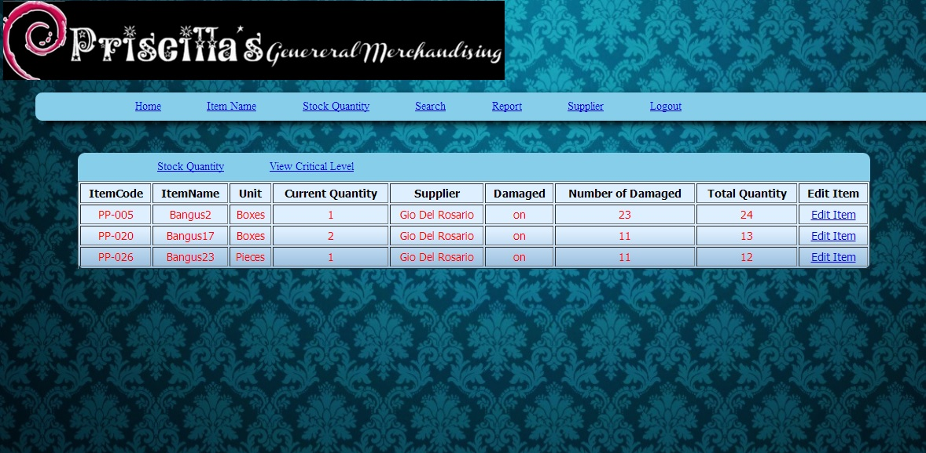

*Figure 4.13 – View Critical Level Page*

4.2.14 **Edit Item**

In this figure 4.7.14 shows the description on the table of the item the user clicks in the stock quantity table in the stock quantity page. It shows the previous contents of the table. It also shows the fill in form where the user could edit the specific item. He could edit the information of the item by editing its current quantity, number of items damaged, parts damaged, and the remarks of the administrator. Current Quantity is the number of items that is ready for sale. Numbers of items damaged are the total amount of items that is not ready for sale or still in repairing phase. Number of items damaged is not included on the current quantity of the item. Parts damaged are the specific part of an item that is damaged or in need for repair. Remarks are the specific feedback of the administrator for the item.

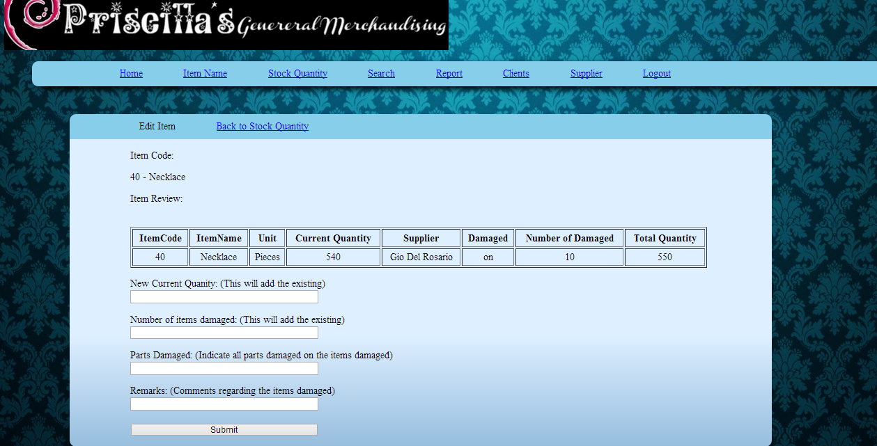

*Figure 4.14 – Edit Item Page*

4.2.15 **Report**

In figure 4.15, it will show a brief report about the inventory. The contents of the table are item code, item name, quantity, and number of damaged. Item code is system generated. Item name is the item or the accessory sold by the company. Quantity is the total number of all items in the inventory. Number of Damaged is the total amount of number of all items that are not ready for sale or still in repairing phase.

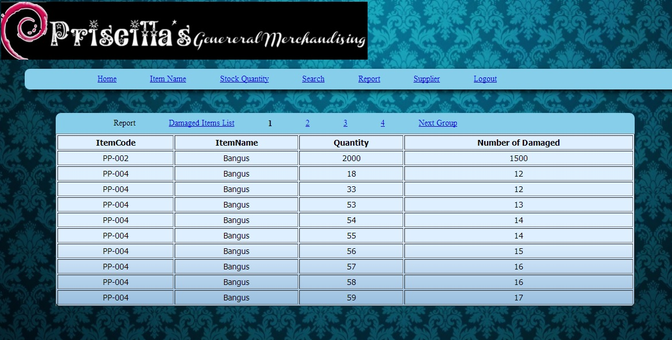

*Figure 4.15 – Items Report Page*

4.2.16 **Damaged Items List**

In figure 4.16, it will show the user all items that are not ready for sale or it is still damaged. The contents of the table are Item Code, Item Name, Quantity, Number of Damaged, Part Damaged, and Remarks. Item Code is system generated. Item name is the item or the accessory sold by the company. Quantity is the total number of all damaged items in the inventory. Number of Damaged is the report of the total number of items that are not ready for sale or still on repairing phase. Part Damaged is the specific part of an item that is damaged. Remarks are the feedback of the administrator for a specific item.

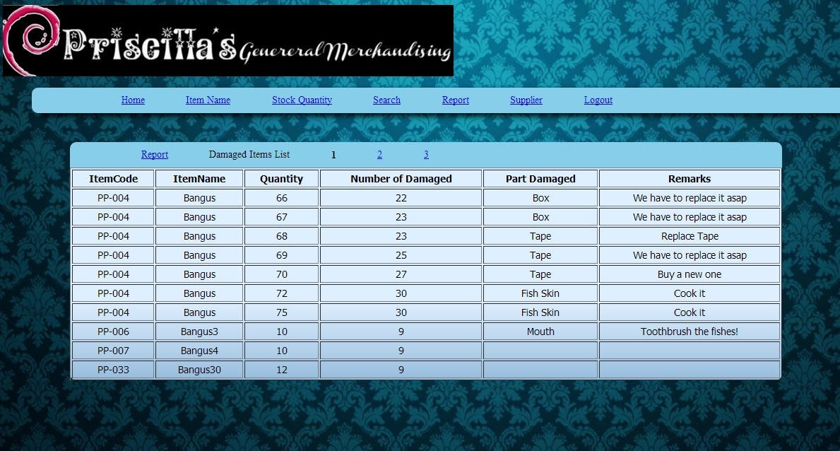

*Figure 4.16 – Report Damaged Items List Page*

4.2.17 **Search**

In figure 4.17, it will show the user a search bar that can be divided into several categories. Categories are Item Code, Item Name, Unit, Current Quantity, Supplier/Customer, Damaged, Number of Damaged, and Total Quantity. The user could search any item based on those categories.

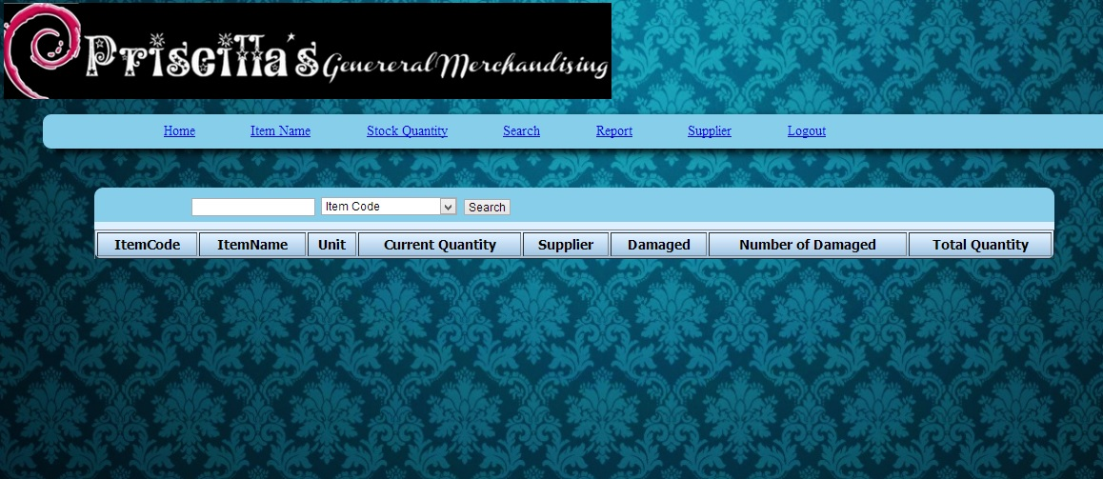

*Figure 4.17 – Search Page*

* **Client Page**

4.2.18 **Home**

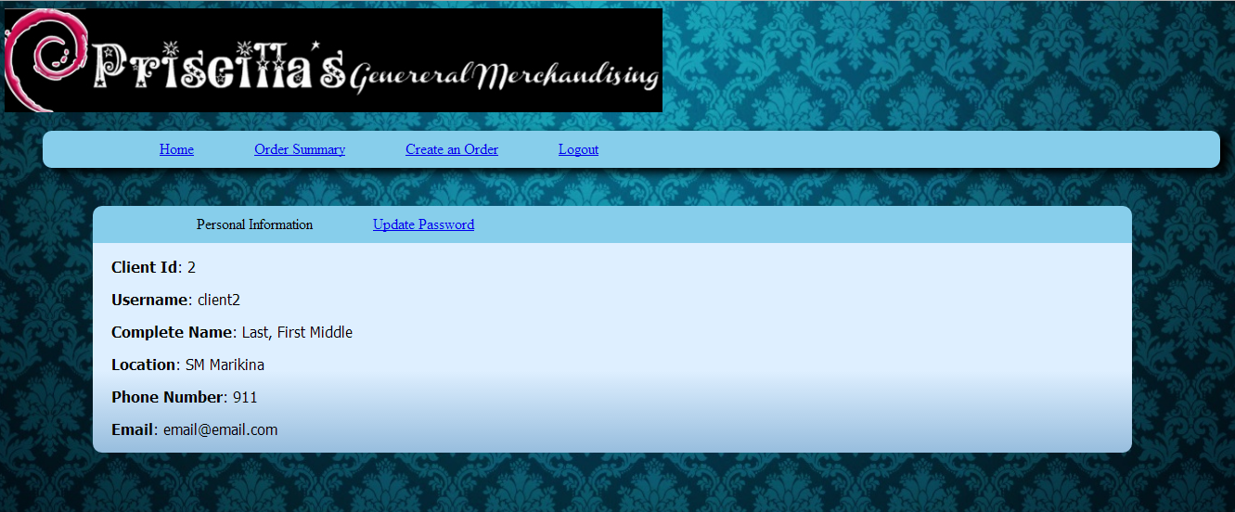 In figure 4.18 is where the user could see the homepage. This is where he could see the company's brief details or brief introduction, which provides the client id, username, complete name, location, phone number, and email. Client id is system generated. Username, complete name, location, phone number, and email is depending on what the administrator registered him to. The client could also update his password that is shown in figure 4.10.2.

*Figure 4.18.1 – Home Page*

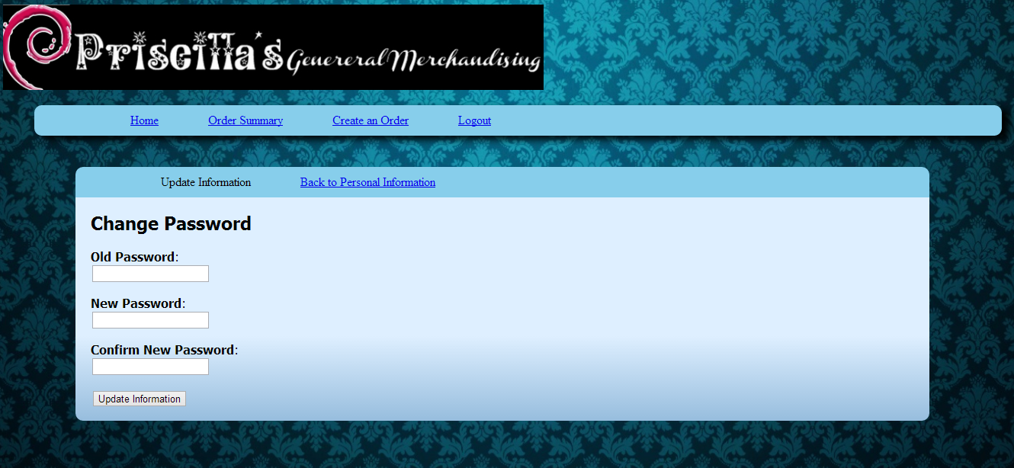

*Figure 4.18.2 – Update Password Page*

4.2.19 **Order Summary**

In figure 4.19, shows the order history made by the client. This is also the order history tab. The contents are the Client ID, Client Name, Location, Product ID, Department, Product Name, Quantity, Date Ordered, Date Received, Lead Time, and Terms & Conditions. The Client ID and Product ID are system generated. The Client Name is based from what the administrator has clicked from the order history. The Location details are based from where the item has shipped. The department details are the category of the items. The quantities are the remaining items left for the items. The date ordered is when the item was ordered. The date received was when the client received the item. The lead-time is the time is based from the interval of the date ordered and date received. The Terms and conditions is the time expected to deliver the products. The user may also print the report.



*Figure 4.19– Order Summary Page*

4.2.20 **Pending Orders**

In figure 4.20 shows that pending orders from the client. The details show the same as the order history but this shows the status of the pending order whether it was received or shipped.



*Figure 4.20 – Pending Orders Page*

4.2.21 **Create an Order**

In figure 4.21 shows on client creating an order for the owner of Priscilla’s’s General Merchandising. The content of the table is the item code, item name, category, unit, unit price, and order item. Item code is system-generated. Item name is the specific name of the accessories of the company. Category is whether it is ladies accessories, children’s accessories or men’s accessories stock. Unit is whether in pieces or in boxes. Price is the amount of money that the items is sold. Order Item is where the client could click the order button that is show on figure 4.21. The user could also search on a specific item depending on his choice of category. Categories are Item Name, Unit, and the price.

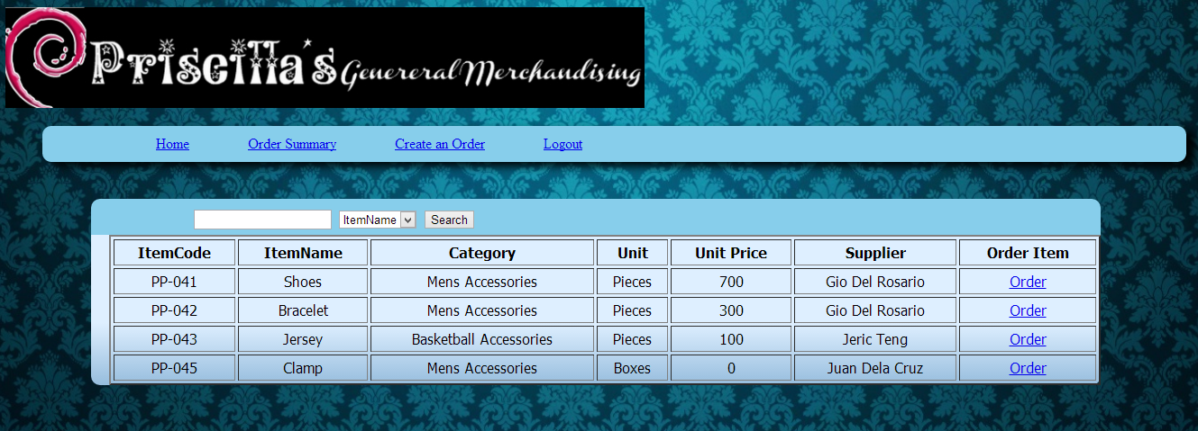

*Figure 4.21 – Create an Order Page*

4.2.22 **Add Order**

In figure 4.22 shows where the user could add order on a specific item. The contents of the table are item code, item name, category, unit, and price. Item code is system generated. Item name is a specific name of an accessory of the company. Category is whether it is ladies accessories, children’s accessories or men’s accessories stock. Unit is based whether it is on pieces or on boxes. Price is the specific amount of money that the items are sold. The user could also enter the quantity by clicking the up down button where it will state the number and will automatically increment when clicking the up button and will also automatically decrement when clicking the down button. The user could also click the certain category whether it is on per piece or per box. Once done, the user could click the confirm button which will prompt the user that the current update is edited/finished.

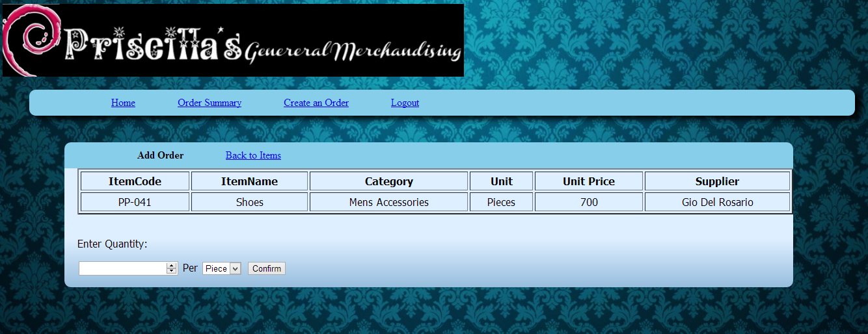

*Figure 4.22 – Add Order Page*

# 5 TECHNICAL REQUIREMENTS DEFINITION AND ANALYSIS

**5.0.1 Performance requirements**

The website should be hosted on a server that can provide progress to the inventory tracking and management. Inventory management should be on a real time basis and accurate essential for the company owner’s decision making. Our site will be built with faster performances to perform such important scenario and cases. Performance is something that’s not to be thought twice but rather it is a need for every system like these. Having a good performance is also having a good view for the system.

System requirement that describes an operational characteristic related to workload measure. These are the requirements identified under this category for the proposed system:

* The system should perform all its functions together with the user requirement on a real time basis.
* The system response or processing time should be standard and satisfactory to the needs of the all the intended users.
* The online inventory system together with its server must be able to handle simultaneous client sessions and still be able to respond and process at a standard given rate.

**5.0.2 Reliability Requirements**

The website that we will be making will contain a contact support if ever the user is experiencing technical difficulties in viewing or interacting. The user will be prompted by error messages, which will be specifically elaborated on what error had occurred. The system will be a user-friendly environment meaning that the site wouldn’t be hard to navigate through. As the user may make confusions on the navigation, he/she may consult on the information assistance panel of the system. The design for the website should have a contrast in which it could also be read the blind.

System requirements that describe the dependability of a system with regards in improving the current system used by the organization and their specific business function/s. These are the requirements identified under this category for the proposed system:

* The system should perform its full functionality effectively and efficiently according to the software specification and configuration.
* The system should be able to recover backups in case of system errors or temporary failure that would be responded by maintenance.
* The system should be able to manage records with regards to the users preference in information management.
* The system should be able to comply with the user’s requirement and should not have a system failure for more than an average of 5 times per year.

## 5.1 Architectural Framework

**5.1.1 Software Architecture**

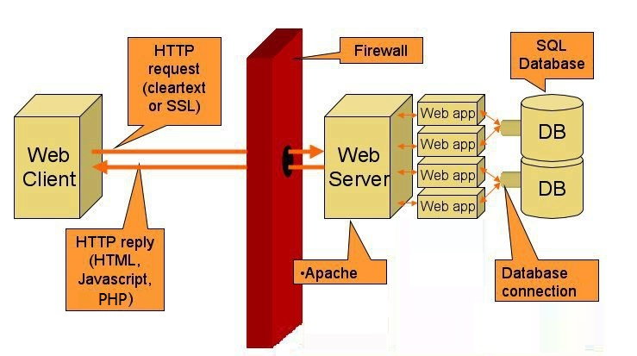

*Figure 5.1 – Software Architecture for the Proposed System*

The diagram describes the infrastructure of the online inventory system for Priscilla’s’s General Merchandising. From the web client the system interacts by the user’s input. The user’s input is translated to language which is the http request formally known as HTML. Then the data is then transmitted to the web server. The web server processes the data inputted by the user. The web server then accesses the database to authenticate, then the system prompts the user when he/she is authenticated or not.

**5.1.2 Physical Data Design**

**5.1.2.1 Database Normalization**

**5.1.2.1.1 Clients**

* **Unormalized**

|  |  |  |  |  |  |  |
| --- | --- | --- | --- | --- | --- | --- |
| Client _ID | Username | Password | Client_name | Branches | Phone_number | Email |
| 1 | adam | pfcheyx | Adam Brown | SM Lipa | 8073623 | adam@adam.com |
| 2 | jones | mcpdys | Jones Tom | SM Makati | 4237483 | [jones@jones.com](mailto:jones@jones.com) |
| 3 | smith | Yxh38fw | Smith Will | SM Lucban | 8647384 | smith@smith.com |

* **1NF**

|  |  |  |  |  |  |
| --- | --- | --- | --- | --- | --- |
| Client_ID | Username | Password | Client_name | Branches | Phone_number |
| 1 | adam | pfcheyx | Adam Brown | SM Lipa | 8073623 |
| 2 | jones | mcpdys | Jones Tom | SM Makati | 4237483 |
| 3 | smith | Yxh38fw | Smith Will | SM Lucban | 8647384 |

* **2NF**

|  |  |  |
| --- | --- | --- |
| Client_ID | Username | Password |
| 1 | adam | pfcheyx |
| 2 | jones | mcpdys |
| 3 | smith | Yxh38fw |

|  |  |  |  |
| --- | --- | --- | --- |
| Client_ID | Client_name | Branches | Phone_number |
| 1 | Adam Brown | SM Lipa | 8073623 |
| 2 | Jones Tom | SM Makati | 4237483 |
| 3 | Smith Will | SM Lucban | 8647384 |

* **3NF**

|  |  |  |  |
| --- | --- | --- | --- |
| Client_id | Username | Password | Client_name |
| 1 | adam | pfcheyx | Adam Brown |
| 2 | jones | mcpdys | Jones Tom |
| 3 | smith | Yxh38fw | Smith Will |

|  |  |  |  |
| --- | --- | --- | --- |
| Email | Client_name | Branches | Phone_number |
| adam@adam.com | Adam Brown | SM Lipa | 8073623 |
| jones@jones.com | Jones Tom | SM Makati | 4237483 |
| smith@smith.com | Smith Will | SM Lucban | 8647384 |

**5.1.2.1.2 Damaged_Items**

* **Unormalized**

|  |  |  |  |  |  |
| --- | --- | --- | --- | --- | --- |
| Item_Code | ItemName | Quantity | Num_dmg | Part_dmg | remarks |
| 1 | ring | 22 | 9 | Diamond | Replace ASAP |
| 2 | necklace | 45 | 30 | lock | Repair ASAP |
| 3 | bracelet | 76 | 42 | string | Repair ASAP |

* **1NF**

|  |  |  |  |  |
| --- | --- | --- | --- | --- |
| Item_Code | ItemName | Quantity | Num_dmg | Part_dmg |
| 1 | ring | 22 | 9 | Diamond |
| 2 | necklace | 45 | 30 | lock |
| 3 | bracelet | 76 | 42 | string |

* **2NF**

|  |  |  |  |
| --- | --- | --- | --- |
| Item_Code | ItemName | Quantity | Num_dmg |
| 1 | ring | 22 | 9 |
| 2 | necklace | 45 | 30 |
| 3 | bracelet | 76 | 42 |

|  |  |  |
| --- | --- | --- |
| Part_ID | remarks | Part_dmg |
| 1 | Replace ASAP | Diamond |
| 2 | Repair ASAP | lock |
| 3 | Repair ASAP | string |

* **3NF**

|  |  |  |  |
| --- | --- | --- | --- |
| Item_Code | ItemName | Quantity | Num_dmg |
| 1 | ring | 22 | 9 |
| 2 | necklace | 45 | 30 |
| 3 | bracelet | 76 | 42 |

|  |  |
| --- | --- |
| Part_dmg | remarks |
| Diamond | Replace ASAP |
| lock | Repair ASAP |
| string | Repair ASAP |

**5.1.2.1.3 Items**

* **Unormalized**

|  |  |  |  |  |  |  |  |
| --- | --- | --- | --- | --- | --- | --- | --- |
| Item_Code | ItemName | desc | unit | sellprice | quantity | supplier | date |
| 1 | Necklace | Good | Box | 9000 | 75 | Anthon Mali | 11-10-13 |
| 2 | Ring | Good | Piece | 500 | 110 | Will Smith | 3-5-13 |
| 3 | Bracelet | Bad | Box | 6000 | 20 | Adam Son | 5-5-13 |

* **1NF**

|  |  |  |  |  |  |
| --- | --- | --- | --- | --- | --- |
| Item_Code | ItemName | sellprice | quantity | supplier | date |
| 1 | Necklace | 9000 | 75 | Anthon Mali | 11-10-13 |
| 2 | Ring | 500 | 110 | Will Smith | 3-5-13 |
| 3 | Bracelet | 6000 | 20 | Adam Son | 5-5-13 |

* **2NF**

|  |  |  |
| --- | --- | --- |
| Item_Code | ItemName | desc |
| 1 | Necklace | Good |
| 2 | Ring | Good |
| 3 | Bracelet | Bad |

|  |  |  |  |  |  |
| --- | --- | --- | --- | --- | --- |
| Unit_id | unit | sellprice | quantity | supplier | date |
| 1 | Box | 9000 | 75 | Anthon Mali | 11-10-13 |
| 2 | Piece | 500 | 110 | Will Smith | 3-5-13 |
| 3 | Box | 6000 | 20 | Adam Son | 5-5-13 |

* **3NF**

|  |  |  |
| --- | --- | --- |
| Item_Code | ItemName | desc |
| 1 | Necklace | Good |
| 2 | Ring | Good |
| 3 | Bracelet | Bad |

|  |  |  |  |  |
| --- | --- | --- | --- | --- |
| **date** | **unit** | **sellprice** | **quantity** | **supplier** |
| **11-10-13** | **Box** | **9000** | **75** | **Anthon Mali** |
| **3-5-13** | **Piece** | **500** | **110** | **Will Smith** |
| **5-5-13** | **Box** | **6000** | **20** | **Adam Son** |

**5.1.2.1.4 Supplier**

* **Unormalized**

|  |  |  |  |  |  |  |  |
| --- | --- | --- | --- | --- | --- | --- | --- |
| id | Name | address | contact | cname | pcontact | pname | category |
| 1 | Lynn Lee | 123 Sampaloc Manila | 8203823 | Chain Industries | 9111 | Cheni Lee | International |
| 2 | Mike Jones | 82 Dimaslang Street | 8638293 | Tom Inc. | 1253451 | Griger Su | Local |
| 3 | Jack Atlas | 192 Neo Domino City | 8563922 | 5Ds Inc. | 8374913 | Yusei Fudo | International |

* **1NF**

|  |  |  |  |  |  |  |
| --- | --- | --- | --- | --- | --- | --- |
| id | Name | address | contact | cname | pcontact | pname |
| 1 | Lynn Lee | 123 Sampaloc Manila | 8203823 | Chain Industries | 9111 | Cheni Lee |
| 2 | Mike Jones | 82 Dimaslang Street | 8638293 | Tom Inc. | 1253451 | Griger Su |
| 3 | Jack Atlas | 192 Neo Domino City | 8563922 | 5Ds Inc. | 8374913 | Yusei Fudo |

* **2NF**

|  |  |  |  |
| --- | --- | --- | --- |
| id | Name | address | contact |
| 1 | Lynn Lee | 123 Sampaloc Manila | 8203823 |
| 2 | Mike Jones | 82 Dimaslang Street | 8638293 |
| 3 | Jack Atlas | 192 Neo Domino City | 8563922 |

|  |  |  |  |  |
| --- | --- | --- | --- | --- |
| Company_id | cname | pcontact | pname | category |
| 1 | Chain Industries | 9111 | Cheni Lee | International |
| 2 | Tom Inc. | 1253451 | Griger Su | Local |
| 3 | 5Ds Inc. | 8374913 | Yusei Fudo | International |

* **3NF**

|  |  |  |  |
| --- | --- | --- | --- |
| id | Name | address | contact |
| 1 | Lynn Lee | 123 Sampaloc Manila | 8203823 |
| 2 | Mike Jones | 82 Dimaslang Street | 8638293 |
| 3 | Jack Atlas | 192 Neo Domino City | 8563922 |

|  |  |  |  |
| --- | --- | --- | --- |
| cname | pcontact | pname | category |
| Chain Industries | 9111 | Cheni Lee | International |
| Tom Inc. | 1253451 | Griger Su | Local |
| 5Ds Inc. | 8374913 | Yusei Fudo | International |

### 5.1.3 Systems Design

**5.1.3.1 Hardware Requirements**

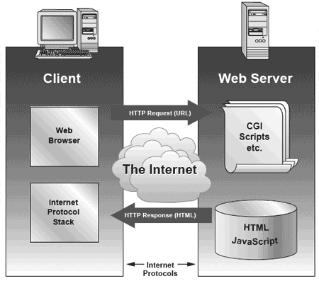

*Figure 5.2 – Hardware Requirements*

In order for business owner and administrators to access the online inventory system for Priscilla’s’s General Merchandising, any laptop / desktop computer with a compatible web browser and internet connection is required. The portal allows real time communication between parties and users on a specific tasks limited to the features of the system.

Here is a detailed hardware requirement for the system:

* Desktop and Laptop computers with Intel processor or later or with low-end speed up to the latest
* Desktop and Laptop computers with AMD processors with low-end speed up to the latest

**5.1.3.2 Software Requirements**

*Table 5.1 – Software Interfaces*

|  |  |
| --- | --- |
| Software Requirements | Description |
| Computer operating system | For best results, compatibility, and functionality, Windows XP and up versions are recommended. |
| Web Browser | For best results, compatibility and functionality, Internet Explorer 7, Mozilla Firefox, and Google Chrome is recommended |
| phpMyAdmin | In the development process, phpMyAdmin is used to handle the administration of  MySQL with the use of the recommended web browser. |
| Database | In the development process, the web database is used to handle the databases of all the records and information within the online inventory system. It is ported through MySQL and phpMyAdmin |
| XAMPP Web Server | In the development process, xampp web server is used create webpages and preview it offline and have a complete and accurate PHP and CSS script editor and also for a good intergration of the web database: MySQL and PhpmyAdmin. |

The website runs on a desktop/laptop. This can also be viewed through mobile platforms and smartphones. It is also compatible with several operating systems such as Windows, Apple, and Ubuntu. The system runs by simply going to a given URL assigned to the site.

Compatible Browsers:

* Microsoft Internet Explorer 8 and up
* Mozilla Firefox 5 and up
* Google Chrome 1.0 and up
* Apple Safari 1.0 and up

Softwarre requirements describe the usability of the system to run in different environments. These are the requirements identified under this category for the proposed system:

* The system will be able to run even on low-end computers regardless of its specification but should conform to the required version of the web browser.
* The system will be able to run on portable and handheld devices such as smartphones and tablets.
* The system will be able to execute from multiple platforms since it is a web-based system.
* Layout and design on webpages should be consistent through different web platforms and browsers.

**5.1.3.3 Supportability Requirements**

System requirement that comprises all activities needed to ensure the operational integrity of the online portal. These are the requirements identified under this category for the proposed system:

* The style sheet used shall be able to be reused over and over again to maintain the consistency of the design of the website.
* Codes and filenames should be rated as a high in priority list so that the developers can easily find the file that needs to be checked in case of bugs and change or update in requirements.
* The online inventory system should be tested and reevaluated on every maintenance phase.
* All updates and new features should be addressed to the system’s users to avoid further conflict and confusion in using new versions.

**5.1.3.4 Security and Privacy Requirements**

The system a log in feature which gives the business owner / administrator to manage the entire inventory system. The administrators have their own username and password, which is used to manipulate the website’s control.

System requirement that describes user access to certain function and the conditions under which access is granted is called the security requirements. It also protects information and data coming from the system for users without access to a specific content. These are the requirements identified under this category for the proposed system:

* The system should be able to identify administrators and all of its users to ensure information and data security.
* The system must be able to guarantee that user identities and accounts are properly confirmed and verified when logging into the system and to all the web forms and information in manipulates.
* All data that are confidential must be kept privately within the system and its users with respective privileges.
* Only the business owners, administrators and all employees who have an account and privelege of Pricilla’s General Merchandising are allowed to enter the online portal.

**6 SYSTEMS TESTING AND QUALITY EVALUATION**

**6.1 System Overview**

The system used by Priscilla’s’s General Merchandising is a manual system where in stock or quantity of the items and accessories are counted of manually. The company uses the traditional pen and paper style when in they keep stack of the number of items. The company does not have a database to keep track of records thus it is hard to identify what needs restocking immediately. The slow process will definitely affect the company and its performance.

The Proposed system has the capabilities to deliver real time quantity of the items stored in the system. The user can view the list of suppliers and how much does this supplier charge the company. Also view items on low level, when an item reach its 20% of the total quantity it prompts the user to restock the said item. The admin can add the items to master item list, where all of items are stored. The stock quantity is where the user can see the items with its current quantity. There the user can also see the report of the items has been updated and what the records show is the history of the items that was added.

**6.2 Test Approach**

**6.2.1 Unit Testing**

This testing is testing part of the system before integrating to the main module of the system. This will be tested by a single client, using a desktop. Here it accepts the inputted data and passes it to the query being made and then the query executes the command given, if the command is successful then it will make changes to the database. It will undergo several algorithms created by the programmer to fulfil the purpose of the inputted data. If the tests are error free then it is use in large scale testing.

**6.2.2 Integration Testing**

The type of testing where it identifies the errors that was not known by unit testing. It is also where the person using this test method would require to identify the cause of error and make the programmer rewrite the code and fix it to be an error free system.

In the proposed system, the system is check regularly. It is also here that the behaviour of the system is check and monitored to do what’s need to be done by the system. The developers are to check first the overall function of the system, that it should not malfunction in anyway and deliver all the necessary data that the client wants.

**6.2.3 Functional Testing**

The requirements for testing a system are an up-to-date web browser, a secure and stable internet connection, a functional operating system, and a database. Web browsers that are up-to-date are Internet Explorer 7 and up version, Mozilla Firefox, and Google Chrome. A database is also required because data are stored in the database.

**6.2.4 User Acceptance Testing**

The purpose of this test is to test whether the developing team is able to understand the requirements of the client and the deliverables are met by the system. This test is performed to determine whether the system fulfills the system requirements and with compliance to the users and other quality assurance tester. The proposed system will be used by client and the one in charge of the store to keep track of the one’s using the system. Here real time testing will be provided to get feedback immediately and address necessary changes if necessary to the programmer. All of the missing components that the user requires will be address here and do what’s necessary changes to the system. Lastly, after all the test have been conducted the institution will choose to approve or disapprove the proposed system.

**6.2.5 Usability Testing**

Usability Testing is a type of testing that evaluates a system that is tested by the users. This is the evaluation of the real users to tell the developing team if the system is easy to use, and see the interaction of the user and the system. This is a necessary test because the developing team will be able get the feedback of the user if the system has provided a good performance or bad performance and if the system has interacted well with its intended user.

**6.3 Test Plan**

**6.3.1 Features to be tested**

The features in our system that are the main modules where this involves the critical path or critical level, the quantity of the items stored in the database, the item master list where all of the items are listed, the supplier page where the supplier list are stored last is the report which holds the transaction data where all of the transactions are listed.

Item Name includes all the item that needs inventorying, in this module there is a table where item name, item code, from which supplier is listed.

The stock quantity page is where items with its quantity is stored and critical level is located. This the main module of the system. Also here the damaged items are check if they are stored for archive purposes.

**6.3.2 Features not to be tested**

The features in our system that might not be tested are the sub modules of the system. This includes the pagantion and login because you cannot access the system if the login fails, no testing is needed.

**6.3.3 Testing Tools and Environment**

The testing tool for the system is automated. The environment requirement needed is an up-to-date web browser which is Internet Explorer 7 and up versions, Google Chrome and Mozilla Firefox, an internet connection, and an operating system which is Windows XP and latest versions.

**6.4 Test Cases**

**6.4.1 Home Page**

|  |  |  |  |
| --- | --- | --- | --- |
| **Input** | **Output** | **Purpose** | **Pass/ Fail Scenario** |
| Click the Home Page Button | Home Page | To view the home page of the website. | **PASS** |
| Click the Item Name | Item Name Page | To view the master list of items in the system | **PASS** |
| Click the Stock Quantity | Stock Quantity Page | To view list of items with its current quantity and total quantity | **PASS** |
| Click the Search | Search Page | To able search the stock quantity for items that needs searching | **PASS** |
| Click the Report Button | Report Page | To view the report page. | **PASS** |
| Click the Supplier | Supplier Page | Views the supplier page and able to see master list of supplier | **PASS** |
| Click the Logout | Main Page | View the login page to asses authentication | **PASS** |

**6.4.2 Login Page**

|  |  |  |  |
| --- | --- | --- | --- |
| **Input** | **Output** | **Purpose** | **Pass / Fail Scenario** |
| Input data in username textbox | Characters of the data are shown | For a user to login his/her account | **PASS** |
| Input data in password textbox | Characters of the data are shown | For a user to login his/her account | **PASS** |
| Click the Submit Button | If the credentials are right, the user could login to his/her account. If the credentials are wrong, the user will be prompted to type his/her username and textbox again | For the system to recognize the user | **PASS** |

**6.4.3 Item Name**

|  |  |  |  |
| --- | --- | --- | --- |
| **Input** | **Output** | **Purpose** | **Pass / Fail Scenario** |
| Click Add item | Views the add item form | Adding an item in master List | **PASS** |
| Item Name text box | Characters | Name of the item to be added | **PASS** |
| Description text box | Characters | The description that the item will contain | **PASS** |
| Drop-Down Unit | Radio Button | Contains the unit of the item to be added | **PASS** |
| Unit Price | Characters | Contains the base price of each item that will be sold | **PASS** |
| Selling Price | Characters | Contains the price of each item that will be sold to customer | **PASS** |
| Quantity | Characters | Contains the number of supply left with the item name | **PASS** |
| Supplier Drop Down | Drop Down | Contains the supplier to which an item belongs | **PASS** |
| Damaged | Characters | Contains the amount of damaged items that were included in the supplier | **PASS** |
| Back to item | Item name page | Will return to item name page | **PASS** |

**6.4.4 Stock Quantity**

|  |  |  |  |
| --- | --- | --- | --- |
| **Input** | **Output** | **Purpose** | **Pass / Fail Scenario** |
| Critical Level button | Critical level page | Contains all the items that needs resupplying | **PASS** |
| Edit item | Edit item page | Edit the items that were stored already in the database | **PASS** |
| Delete button | Delete Button | Deletes the button that were included in the system | **PASS** |

**6.4.5 Search**

|  |  |  |  |
| --- | --- | --- | --- |
| **Input** | **Output** | **Purpose** | **Pass / Fail Scenario** |
| Dropdown | Drop down search | Categorized which column needs searching | **PASS** |
| Search | Button | Searches the database with the column in mind | **PASS** |

**6.4.6 Report**

|  |  |  |  |
| --- | --- | --- | --- |
| **Input** | **Output** | **Purpose** | **Pass / Fail Scenario** |
| Damaged Item List | Damaged List page | Contains all the damaged item in a table form | **PASS** |

**6.4.7 Supplier**

|  |  |  |  |
| --- | --- | --- | --- |
| **Input** | **Output** | **Purpose** | **Pass / Fail Scenario** |
| Name | Characters | Name of the supplier to be added | **PASS** |
| Address text box | Characters | The Addresses that the supplier will contain | **PASS** |
| Company Name | Characters | Contains the company name of the supplier | **PASS** |
| Company Number | Characters | Contains the contact number of the supplier | **PASS** |
| Supplier Contact | Characters | Contains the direct supplier you are having transaction with | **PASS** |
| Person to contact incase | Characters | Contains the another supplier | **PASS** |
| Emergency Contact number | Characters | Contain another number for the 2nd supplier | **PASS** |
| Submit | Supplier Page | Adds the necessary data to database and goes back to supplier page | **PASS** |

## 7 CONCLUSIONS AND RECOMMENDATIONS

## 7.1 Conclusions

For us to fully grasp and understand the company’s business problems/needs set of interviews and observation was conducted as the development progresses. Understanding the current business process gave us ideas and preliminary concepts on how we would improve it and set the company owner’s requirement as the top priority. The project team fully grasps the knowledge about every information regarding the business processes of Priscilla’s’s General Merchandising and was able to come up for the best solution to provide development for the business’ needs.

This research study and the entire proposed system was an important element for the development of the whole business process and the improvement of the current system that the business is using. All of the redesigned process proved that with the adaptation of the proposed workflow and the implementation of the proposed system caused an increase of efficiency, reliability and accuracy to the business process and especially with inventory management for Priscilla’s’s General Merchandising. The study was proven feasible and was able to meet the client’s requirements that will accommodate the lacking elements for the business needs. The study is now considered as an essential asset for the company.

Based on the solution implemented and testing conducted the study was able to meet the client’s requirements and the project’s objectives. The system helps Priscilla’s’s General Merchandising to track inventory goods from production until the distribution of finished products and enhance production speed and efficiency by the integration of technology and to monitor the products systematically that can also generate reports to help the company owner in decision making. The system and the project was also able to integrate technology that will help facilitate records of transactions that are normally presented in a physical file and to be able to produce business reports about the status of inventory goods, sales and revenue of the company that will aid the company owner on what are the business strategies that he must follow.

All of the stated the stated project objectives was a perfect match and compliment to the client’s requirements to improve their business functions. This was accomplished by carefully analyzing the best way on how to live up to the expectations of both parties; the company owner and the project team.

## 7.2 Recommendations

Computer-based system is a complex system wherein information technology plays a major role. It makes the work easier, faster and more accurate. Due to that fact, the automated scheme has become essential to small and big companies for they are expected to give the best services possible. Companies nowadays are recommended to switch from manual to automated systems because this will improve the efficiency and productivity of the business, which will uplift the industry’s reputation.

Improvements to Priscilla’s's General Merchandising inventory processes require the automation of the company's inventory system. We recommend that a dedicated computer system and database be used to store information about items on hand, in addition keeping track of quantities. The database will also be able to keep track of those items that have been purchased and those items that will be sold on customers. Critical items are also tracked in the system so the owner of the company could see what items are needed to be a priority one. Item codes are system-generated.

For the implementation of this system, a computer with valid login details is needed. This will allow users to access the database of items.